24.28: a) 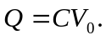
b) They must have equal potential difference, and their combined charge must add up to the original charge. Therefore:
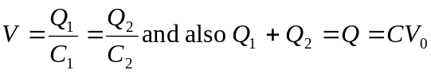
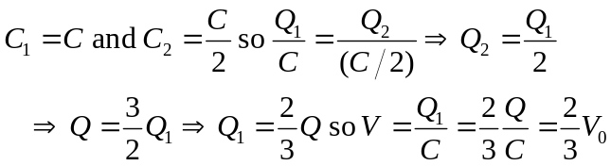
c) 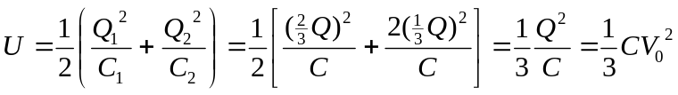
d) The original U was 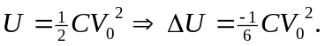
e) Thermal energy of capacitor, wires, etc., and electromagnetic radiation.

